Task 2 Important Terms
General concepts
Supervized learning – We know what the output should be, and we train the model to classify the data into the labela that we want.
Unsepervized learning – We don’t know the ideal output, so the model identify the pattern without knowing what actually us.
Gradient descent - An optimization algorithm used to minimize a loss function by iteratively adjusting parameters (weights) in the direction of the negative gradient.
- Think: “walk downhill until error is small”
- Update rule:
$$w=w-α⋅∇J(w)$$
- α = learning rat
Basically, how the model learn.
Difference between front/backpropagation from this?
The gradient descent is the optimizer, it doesn’t care how gradients are computed, its just uses them. While backpropagation is the algorithm to compute gradients to be updated.
Logistic Regression - A classification algorithm that models probability using a sigmoid function.
- Output: probability between 0 and 1
- Used for binary classification
- Decision boundary is linear
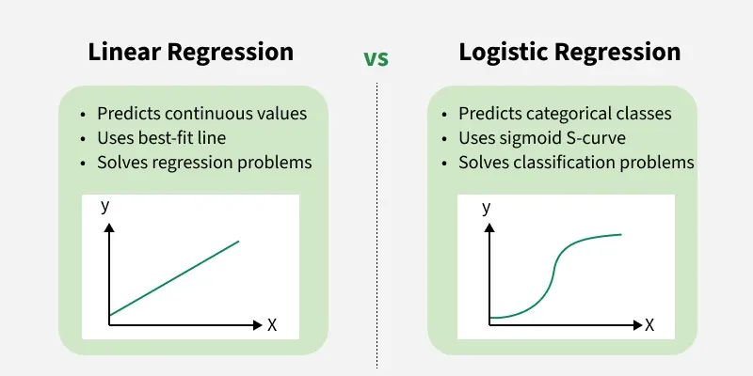

Bias / Variance Tradeoff
- Bias: inability for a machine learning method to capture the true relatioship of the data
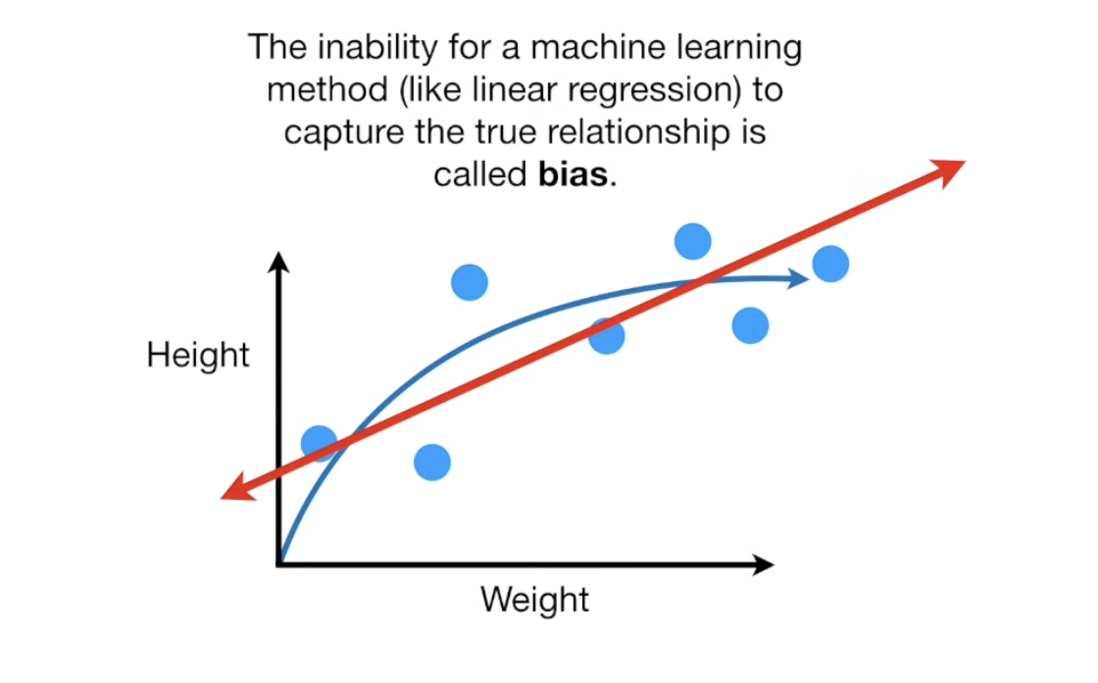
- Variance: how sentitive is a model to test data set
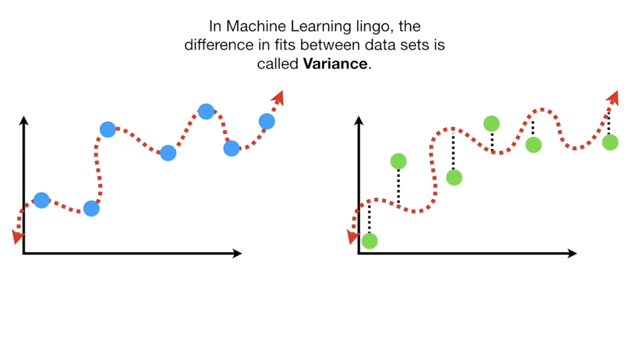
Goal: balance both
Regularization - Technique to prevent overfitting by penalizing large weights. Visually, makes the line correct for our desired output. Its like saying, “don’t trust any single feature too much” [1]
- L1 (Lasso): promotes sparsity
- L2 (Ridge): smooth weight reduction
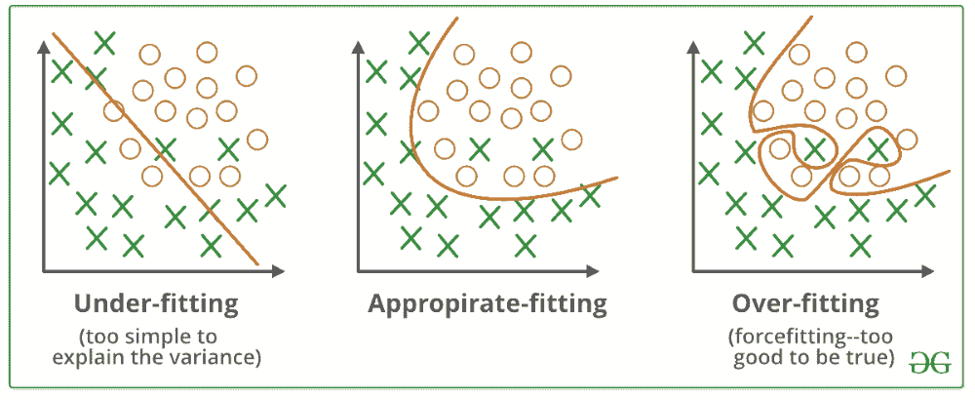

Data Augmentation - Modify existing data to create new variations os it. This way you create more data than the original, so the model have more information to train on.
Dimensionality reduction – reduce number of features
Bootstrapping - Data technique, ampling from your dataset with replacement to create new datasets. Some can be repeateed or disappear. Mainly use to estimate uncertainty or trian multiple models.
Emsemble - Use the output of n numbers of models and use them to have better prediction of the output. Herre enters bagging and boosting.
Bagging - Combine multiple bootstrap datesets, training a separate model with the different data and combining predictions. This reduce variance because each model have its own way to “see” things.
Boosting - Train models in sequence, each model focusing on fixing the errors of the model before.
General Machine Learning
Supervized learning
K nearest neighbors (KNN) – non parametric algorithm. We average the value of k, so calculate the output by taking the average of those who are close to the new point.
Naïve Bayes Classifier – Use probabilities, we count the encouenter of something and base on that we determine the % of something. Mainly use to identify spam
Decision tree – create a tree that answer yes or no question to classify
Unsupervized learning
Clustering – like classification BUT we don’t know the classes to be identify.
K-means clustering – clustering but knowing how many classes you want to identify.
Support Vector Machines
Why is it called Support Vectors?
Because only a subset of data points (the “support vectors”) define the decision boundary. These are the closest points to the boundary.
What is difference between Support Vector Classifiers and Support Vector Machines
• Support Vector Classifier (SVC): linear boundary
• Support Vector Machine (SVM): can use kernels → nonlinear boundaries
Concepts:
- Hyperplane - A decision boundary separating classes. In 2D, it would be a line, in 3D a plane
- Support Vectors – Data points closest to the hyperplane, they control the positio of the boundary
- Margin - Distance between hyperplane and closest point
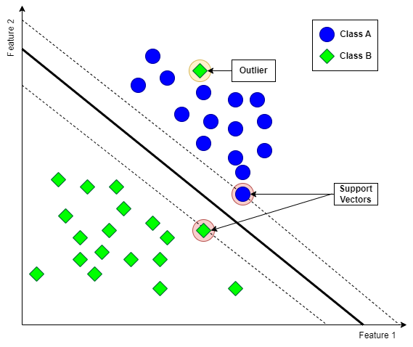
- Kernel - Function that transforms data into higher dimensions. Allow nonlinear separation
- Hard Margin – Exact space between values, doesn’t allow misclassification. Good if the data is well divided
- Soft Margin – Allos more space between values, it allows misclassification, more realistic.
- C (Regularization parameter) – High C, less tolorence to errors, low C, more tolorence
- Hinge Loss – Loss function used in SVM, penalizes points inside margin or misclassified
- Dual Problem - an alternative formulation derived from an original “primal" problem, designed to provide a lower bound (for maximization) or upper bound (for minimization) on the optimal value. Important because it allows use of kernels.
- Radial Base Function Kernel - A kernel that measures similarity based on distance.
- Gaussian Kernel - measures similarity between data points using a bell-shaped curve.
- One-Versus-One – is a multiclass classification strategy that breaks down a K-class problem, training each model to distinguish between a specific pair of classes.
- Outputs (Not a probability) - SVM outputs a distance from hyperplane, not probability.
- Lagrangian multiplier method - is a strategy for finding the local maximum or minimum of a function f(x, y, z) subject to equality constraints g(x, y, z) = c.
- Kernel Trick - Instead of computing high-dimensional transformation explicitly, compute inner products using a kernel.
- Feature Space - Higher-dimensional space where data becomes separable.

Neural Networks
Single Layer perceptron:

- Inputs (x) - features
- Bias (b) – shift output
- Weights (w) – importance of each input
- Weighted Sum – z = w * x + b
- Activation – transfrom output
- Output – final prediction
- Error – difference from true value

Why use activations?
Without activation, the model is just linear. When we use it, it allos the model to learn complex patterns.

What does it mean to be Non-Linear?
It means that models can learn relationships that are not stright line, it allows the line that define the labels to be curves or complex shapes.

Types of activations in Perceptrons:

- Unit Step – 0 or 1, hard threshold
- Signum - -1 to 1
- Linear – f(x) = x, no transformation
- Piecewise Linear - Combination of linear segments.
- Logistic (Sigmoid) – used probabilities
$$f\left(x\right)=\frac{1}{1+e^{-x}}$$
- Hyperbolic Tangent – f(x) = tanh(x), output -1 to 1
- Relu – f(x) = max(0, x), more used
- Rectifier SoftPlus – f(x)=ln(1+e^{x}), smooth version of ReLU

Reference
- GeeksforGeeks, “Regularization in machine learning,” GeeksforGeeks, Dec. 11, 2025. https://www.geeksforgeeks.org/machine-learning/regularization-in-machine-learning/
- R. Andreoni, “Support Vector Machine with Scikit-Learn: A Friendly Introduction,” Towards Data Science, Jan. 18, 2025. https://towardsdatascience.com/support-vector-machine-with-scikit-learn-a-friendly-introduction-a2969f2ff00d/
- GeeksforGeeks, “OnevsRest strategy for MultiClass Classification,” GeeksforGeeks, Jul. 15, 2025. https://www.geeksforgeeks.org/machine-learning/one-vs-rest-strategy-for-multi-class-classification/
- Dr. Trefor Bazett, “Lagrange Multipliers | Geometric Meaning & Full example,” YouTube. Nov. 27, 2019. [Online]. Available: https://www.youtube.com/watch?v=8mjcnxGMwFo
- StatQuest with Josh Starmer, “Machine Learning Fundamentals: Bias and Variance,” YouTube. Sep. 17, 2018. [Online]. Available: https://www.youtube.com/watch?v=EuBBz3bI-aA
- Infinite Codes, “15 machine learning lessons I wish I knew earlier,” YouTube. Oct. 31, 2024. [Online]. Available: https://www.youtube.com/watch?v=espQDESe07w
- StatQuest with Josh Starmer, “Support Vector Machines Part 1 (of 3): Main ideas!!!,” YouTube. Sep. 30, 2019. [Online]. Available: https://www.youtube.com/watch?v=efR1C6CvhmE
- StatQuest with Josh Starmer, “Support Vector Machines Part 2: The Polynomial Kernel (Part 2 of 3),” YouTube. Nov. 04, 2019. [Online]. Available: https://www.youtube.com/watch?v=Toet3EiSFcM
- StatQuest with Josh Starmer, “Support vector Machines Part 3: The radial (RBF) kernel (Part 3 of 3),” YouTube. Nov. 04, 2019. [Online]. Available: https://www.youtube.com/watch?v=Qc5IyLW_hns
- StatQuest with Josh Starmer, “Gradient descent, Step-by-Step,” YouTube. Feb. 05, 2019. [Online]. Available: https://www.youtube.com/watch?v=sDv4f4s2SB8
- Infinite Codes, “All Machine Learning algorithms explained in 17 min,” YouTube. Sep. 17, 2024. [Online]. Available: https://www.youtube.com/watch?v=E0Hmnixke2g

